Top Ten Literacy Ideas You Must Try This Year
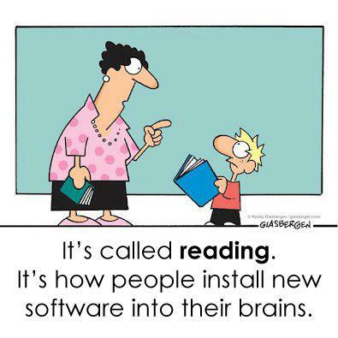

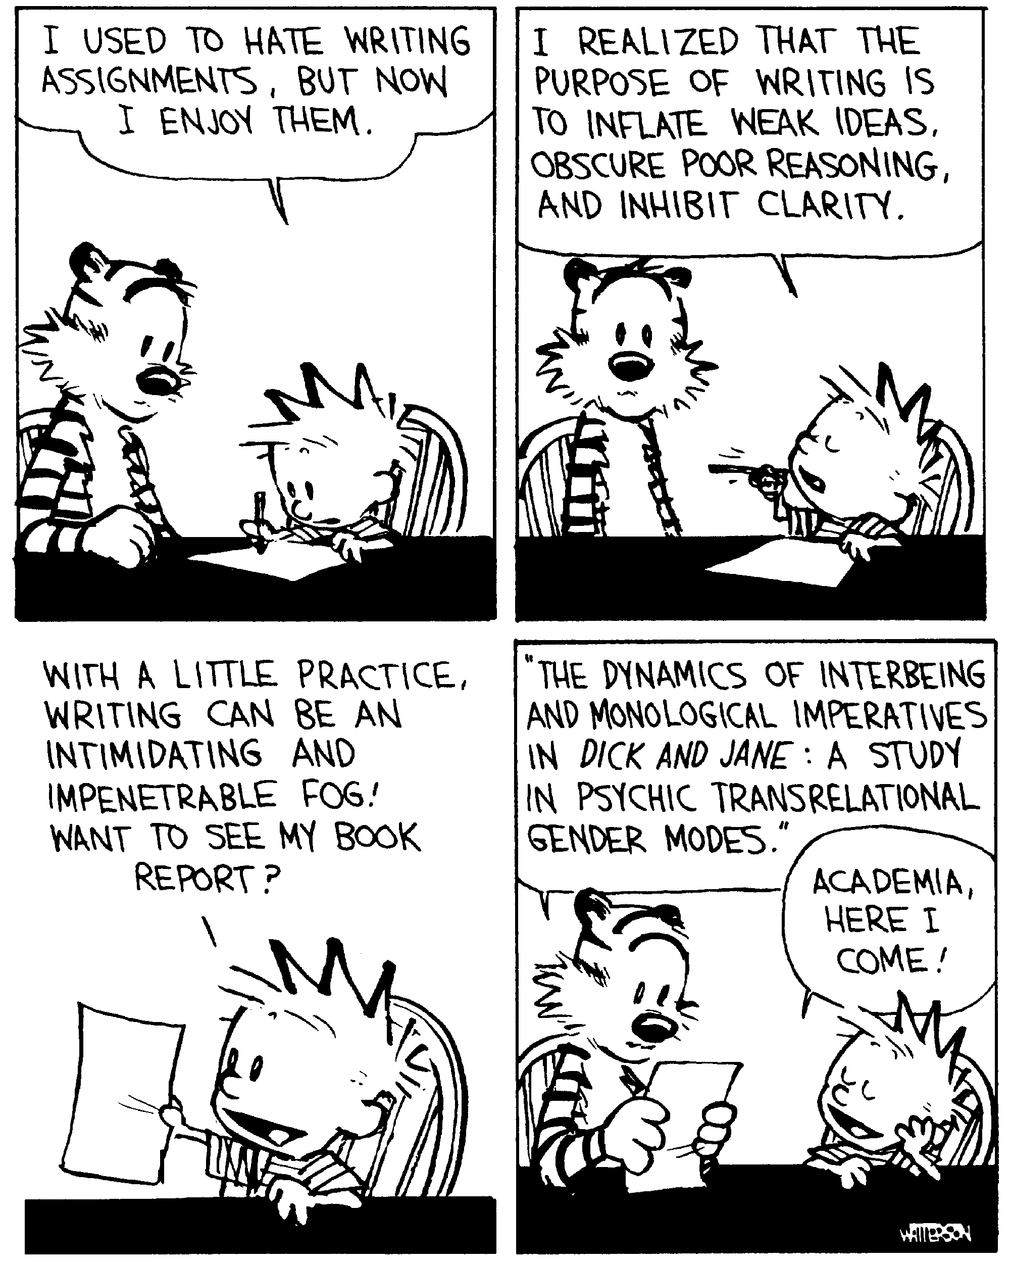
This is a resource for science teachers, science teachers who would like to improve the literacy skills of their students.

If you are a science teacher who isn’t interested in literacy, what are you thinking? Haven’t you looked at an NCEA paper recently?

Aaron Wilson working on the Secondary Literacy Project identified the following common assumptions among teachers

- Literacy should be taught in the English dept
- In Science we should:
  - minimise opportunities for students to read independently
  - simplify the texts that students read and write
  - summarise the text for students e.g. providing notes to copy
  - always provide scaffolding
  - provide vocab activities

The problem with this approach is

Students in a particular class begin the year with lower reading comprehension than their peers in another class

In response, their teachers give them fewer opportunities to read, and when they do, the texts are simplified

Therefore, they get less exposure to rich and authentic texts than their peers

So, the gaps in reading comprehension between the two groups get even bigger

So let’s break the cycle and teach literacy as an integral part of our subject, this doesn’t mean more content it means approaching the content with a literacy slant that covers both skills and content.

Turning Assumptions Around

- Literacy needs to be taught in the Science department
- In Science we need to:
  - maximise opportunities for students to read independently
  - teach students how to manage texts beyond their current ability
  - summarise the text with students - teach them different strategies to find key ideas
  - scaffold‘in’ but also scaffold ‘out’ so we help initially but then students can do it themselves
  - provide vocab & reading & speaking & writing activities in context and with a clear purpose
- Remember effective teaching and learning involves high challenge and high support

The activities on the following pages are not the only activities you could use but provide a possible starting point for teachers who know they should be involved but aren’t sure where to start.

For more ideas or to start a discussion why not register on the TKI subject literacy forum

http://literacyonline.tki.org.nz/Literacy-Online/Community-discussions/Secondary-Literacy

http://literacyonline.tki.org.nz/Literacy-Online/Secondary-Literacy/Teacher-needs/Literacy-in-the-learning-areas2/Literacy-in-Science

For more support or to share resources or student work contact
i.mchale@auckland.ac.nz Secondary Science Facilitator at Team Solutions

Reading 1 Three level guides

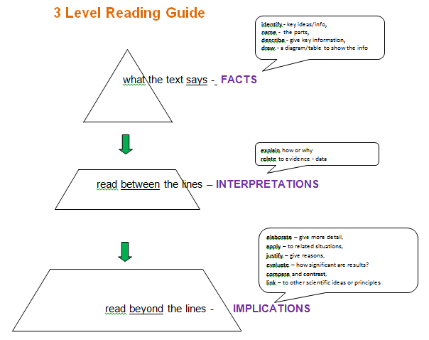

Find an appropriate text to write a three level guide

For more support look at the examples on ESOL TKI

http://esolonline.tki.org.nz/ESOL-Online/Teacher-needs/Pedagogy/ESOL-teaching-strategies/Oral-language/Teaching-approaches-and-strategies/Reading/Three-level-reading-guides

or

http://esolonline.tki.org.nz/ESOL-Online/Teacher-needs/Pedagogy/ESOL-teaching-strategies/Reading/Three-level-guides

Reading 2 Reciprocal Reading (Helen Nicholls)
The aim for reciprocal reading is for the students to use strategies for extracting meaning from reading, which good readers do automatically.

First assign groups and pick a leader, the leader assigns the roles and the first predictor makes their prediction of their passage

Reading the Text.
Either Everyone in the group reads a short section individually.(This strategy is best used when all can read fluently).
Or One person reads and the others follow the text.(This is a good strategy to use when you have a mix of very confident readers willing to lead and some less confident readers).

Then the clarifier, questioner and summariser get their turns.
Rotate the roles for each paragraph

Defining the roles
The Leader:
Decides who will do each job, introduces the
text and makes sure everyone is joining in.
The Predictor:
Encourages all learners to make logical predictions
and use information from their wider knowledge, and personal
experiences to predict what will be in the text.
The Clarifier:
Helps the group to identify confusing words, sentences and ideas.
They then encourage the group to reach a
shared understanding of the text.
The Summariser:
Helps the group to identify the most important ideas in the text using known summarising strategies.
The Questioner:
Asks questions which encourage full understanding of the text; allows the group to analyse the text and
help the group to evaluate the text

Rotate the roles for each paragraph
The teacher can then lead a whole class discussion about the text to ensure that all learners have met the success criteria. Follow up activities could include summarising, mind mapping and using the
information to create new tasks.

More information at
http://literacyonline.tki.org.nz/Literacy-Online/Teacher-needs/Reviewed-resources/Reading/Comprehension/ELP-years-5-8/Reciprocal-teaching-of-reading
or
http://www.educationcounts.govt.nz/__data/assets/pdf_file/0017/107108/BES-Exemplar4.pdf

The following sheets may be helpful to remind students of roles,

Leader | Predictor | Clarifier | Questioner | Summariser
Organise the reading, assign the roles | Have a quick look at the text and predict what it will be about | Pick out any confusing ideas and discuss them in the group | Ask questions to make sure everyone understands the texts | Summarises the key ideas in the text
Leader | Predictor | Clarifier | Questioner | Summariser
Organise the reading, assign the roles | Have a quick look at the text and predict what it will be about | Pick out any confusing ideas and discuss them in the group | Ask questions to make sure everyone understands the texts | Summarises the key ideas in the text
Leader | Predictor | Clarifier | Questioner | Summariser
Organise the reading, assign the roles | Have a quick look at the text and predict what it will be about | Pick out any confusing ideas and discuss them in the group | Ask questions to make sure everyone understands the texts | Summarises the key ideas in the text

Reciprocal reading will not just happen first time you will need to model and persist, eventually students will be carrying out all the roles themselves.
For research background see
http://literacyonline.tki.org.nz/index.php/ESOL-Online/Teacher-needs/Pedagogy/ESOL-teaching-strategies/Oral-language/Teaching-approaches-and-strategies/Reading/Co-operative-reading-Reciprocal-teaching
Reading 3 Talking to the Text TttT(Cynthia Greenleaf)
Talking to the text is another method to encourage the metacognition that goes on when good readers read.

Prepare a text for the students to read but ensure there are margins all around the page and room to write on the sheet.

First of all the students do a ‘high flight’ over the passage, look at it without reading it. They might circle or highlight key clues. Then they make a prediction about what the text is about.
The teacher may wish to have a discussion at this stage.

Then they read the text alone and annotate it, they can ask questions, make notes, note connections, designate unfamiliar vocabulary, summarise or make predictions.

The following sentence starters might help
- A question I have is…
- This is like…
- I don’t understand …
- So what it’s saying is…
- I think this means…
- This reminds me of…
- This would be good for…
- In summary…
- I think that..
- This helps me understand…
The students could then pair and discuss their annotations and then to larger groups.
Teacher could then help with words, or ideas, which are hindering understanding. The students engage with the text independently without the expectation they will completely understand it
For research info and examples see
Reading For Understanding - Schoenbach, Greenleaf & Murphy http://www.wested.org/resources/reading-for-understanding-how-reading-apprenticeship-improves-disciplinary-learning-in-secondary-and-college-classrooms-2nd-edition/
http://readingapprenticeship.org/research-impact/videos/classroom/
Reading 4 Identifying other clues
Provide students with examples of questions from the Te Reo NCEA papers, found on NZQA with other past papers

Ask students to look at the information they can understand and predict what the question could be. In chemistry papers and physics papers it is often clear from the diagrams and data. Students will hopefully be more aware of the visual clues they need to decode text completely.

NB- We are not suggesting they do not read the question but that they look carefully at the other information which they have as well as the text
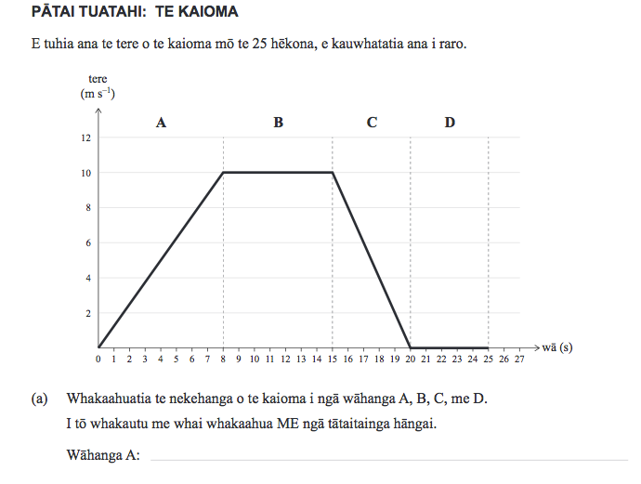
It’s interesting to note that since the realignment questions tend to have less non-text clues
This is where you find Pepe Whakamatautau
http://www.nzqa.govt.nz/ncea/assessment/search.do?query=Science&view=exams&level=01
Reading 5 SCRIP comprehension
SCRIP comprehension is a technique,similar to reciprocal reading, where students work alone to understand a text.
Readers fail to understand text because they lack cueing strategies to prompt effective interaction with what the text says. Reading research is clear that readers who internally monitor their own reading with self-questioning strategies understand and retain textual information far better than readers who simply passively read text. These cueing strategies to increase reading comprehension are more efficiently “taught,” rather than just “caught.”

The five SCRIP reading comprehension strategies teach readers how to independently interact with and understand both narrative and expository text to improve reading comprehension. The SCRIP acronym stands for Summarize, Connect, Re-think, Interpret, and Predict.

Take the time to explicitly teach and model the five strategies. Emphasize one strategy at a time on a given text. Use both narrative and expository texts to demonstrate how the SCRIP Comprehension Strategies can be applied to any reading. Have students practice verbalizing and writing down the SCRIP strategy responses. Post a SCRIP chart or make SCRIP bookmarks for student reference.

Summarize means to put together the main ideas and important details of a reading into a short-version of what the author has said. A summary can be of an entire reading, but it is more useful to summarize more than once at key transition points in the author’s train of thought. It frequently requires the reader to skim that part of the reading once more.

Connect means to notice the relationship between one part of the text with another part of the text. The parts may compare (be similar) or contrast (be different). The parts may be a sequence (an order) of events or ideas. The parts may respond to other parts of the text, such as to provide reasons for or effects of what came before in the reading. Next, Connect also means to examine the relationship between one part of the text with something outside of the text. It could be something from another book, movie, television show, or historical event. Finally, Connect also means to see the relationship between one part of the text with your own personal experience. You may have had a similar experience in your own life to that described in the text.

Re-think means to re-read the text when you are confused or have lost the author’s train of thought. Reviewing what has just been read will improve understanding. You may even understand what the author has said in a different way than how you understood that section the first time reading it.

Interpret means to focus on what the author means. Authors may directly say what they mean right in the lines of the text. They also may suggest what they mean with hints to allow readers to draw their own conclusions. These hints can be found in the tone (feeling/attitude) of the writing, the word choice, or in other parts of the writing that may be more directly stated.

Predict means to make an educated guess about what will happen or be said next in the text. A good prediction uses the clues presented in the reading to make a logical guess that makes sense. Good readers check their predictions with what actually happens or is said next.

Using the SCRIP reading comprehension strategies will make a difference in the reading abilities of your students.

For more details look at

http://penningtonpublishing.com/blog/reading/how-to-increase-reading-comprehension-using-the-scrip-comprehension-strategies/

For a sheet of bookmarks for students go to

http://penningtonpublishing.com/blog/wp-content/uploads/2009/01/SCRIPBookmarks1.pdf

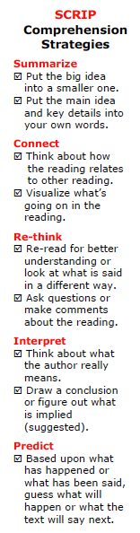

Writing 1 Rally Table
Two students work together, they are given a topic to think about and a piece of paper. The first student writes a keyword and passes onto the second who writes a word and passes it back, this continues for a fixed time.
There is a competitive element, which some students enjoy. The teacher asks which pair has the most words and writes them on the board in two columns.

Then asks the group if there are any really important words they would like to add or words that aren’t relevant

Then the students have to write sentences, which include a word from each column

This would be a good time to let students share sentences and check for misconceptions.

Finally students write a paragraph around the topic using the language discussed throughout the lesson

Good for prior knowledge work or summary work

Example Acids and bases

Acid Base
Indicator pH
Neutralise Proton
Hydrochloric acid Sodium hydroxide
Water Seven

Writing 2 Word Targets
To help identify key vocabulary and think about what words are more important or relevant or improve the answer

Hand out the sheet on the next page and give the students a question to answer, write the question in the middle.

Now the students add key words they must, should and could use in their answer. All words are not equal.

This means they are starting to identify the main ideas before they start writing and not just brainstorming key words, could do a word rally first then they could identify which keywords are important.

Example How are Igneous rocks formed?

Must
Lava/magma, cooling, solidifies

Should
Crystals, intrusive, extrusive, size, volcano, liquid, solid

Could
Granite, scoria, pumice,

It is hard to imagine an answer that doesn’t use the must words being a good answer, the should and could words could definitely improve the quality and depth of the answer

Word Targets – Aiming for good answers
Could

Should

Must

Question

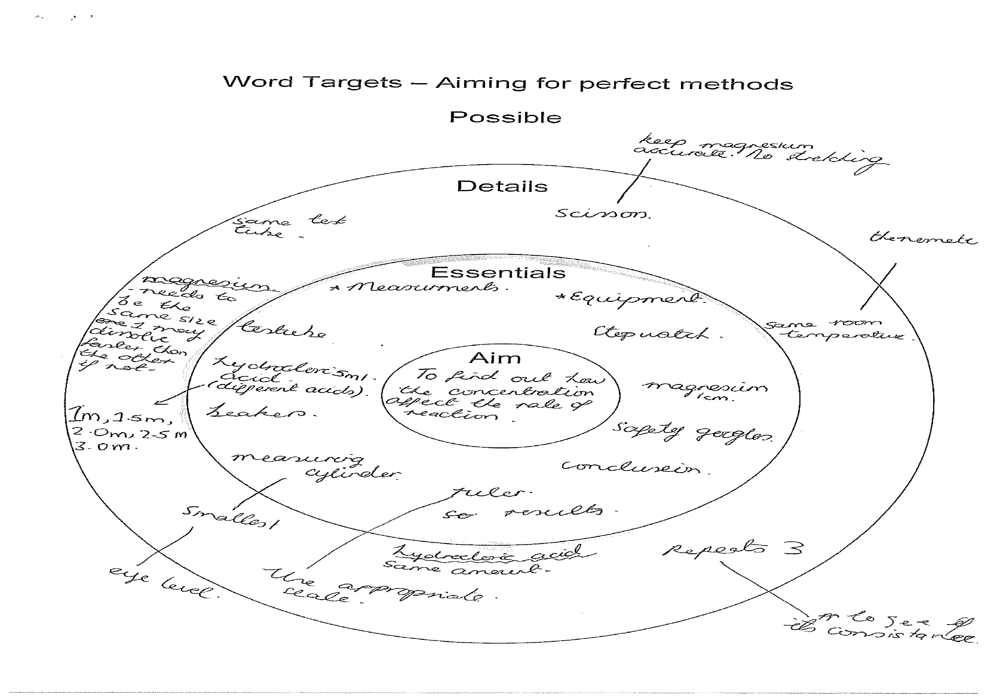
In this example a student has planned a method for an investigation, this hopefully helps them appreciate that a method can be improved with more detail

Writing 3 HOT SOLO Maps
HOT SOLO (Hooked on Thinking Structure of Observed Learning Outcomes) Templates are collected in a book by Pam Hook and Julie Mills –SOLO Taxonomy: A guide for Schools, A common language of learning Book 1.

The maps can be used immediately as scaffold for writing but are much more useful when used with an understanding of SOLO taxonomy and combined with the self assessment rubrics provided.

There are also useful vocabulary tables for each map which will help students write connected statements and look at connected ideas in a new way.

Over the next few pages are the pages relevant to the compare and contrast map but the book contains the following maps
Define
Describe
Sequence
Classify
Cause and effect
Analyse
Analogy
Generalise
Predict
Evaluate

Which are all useful. I have found for older students the ‘overall’ boxes are quite limiting and I usually get students to fill in the template then turn over the sheet and write their full answer using the target vocabulary before they assess their success using the rubric. This leads to much better writing
More info available at http://pamhook.com/hooked-on-thinking/
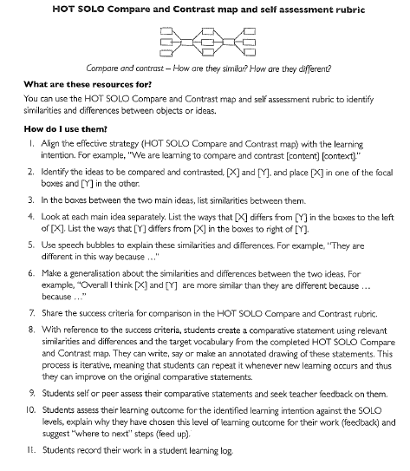
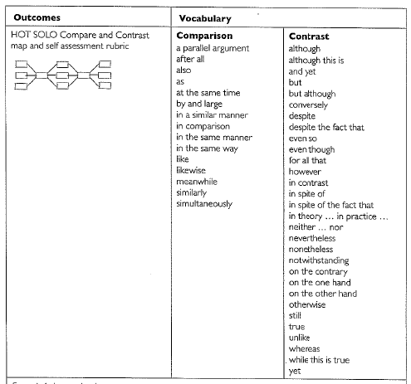

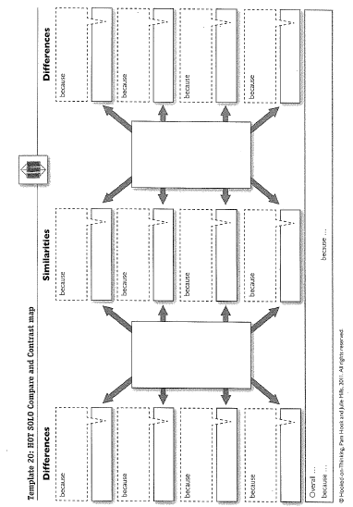
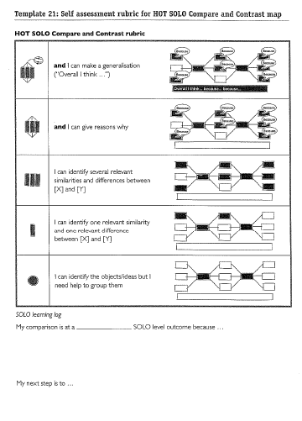

Writing 4 – NCEA Linking Language
We always provide students with vocabulary lists for the relevant science topic but we also need to help students with linking words. NCEA markers are often looking for linking words as much as relevant science vocabulary. Give students the following information and ask them to write a describe, an explain and a discuss answer for the same topic.

Describe requires the  student to define,  give characteristics of,  or an account of. | Explain requires the  student to provide a  reason as to how or  why something occurs. | Discuss requires the  student to show  understanding by  linking ideas.  It may involve students  in elaborating, applying,  justifying, relating,  comparing & contrasting,  evaluating, analysing.
Initially  The first step  Secondly  Subsequently  Following this  Before  Then  Later  For example | Consequently  Such as  As follows  However  Also  As well as  Due to  Because of  The reason for  Hence  Since  The effect of  Therefore  An outcome of  Accordingly  As a result of | Both … and …  Similarly  Not only… but also …  However  On the other hand  Alternatively  In contrast to  Although  Nevertheless  If … then…  As can be seen by  According to  Evidence indicates  Therefore  Accordingly  To summarise

Writing 5- Note taking and summarizing
Students are often having to collect information from several sources and then explaining their understanding. This is occurring in several research standards.

Students need practice in selecting relevant information, recording where it came from and synthesizing it into their own words. The template on the next page gives them a basic scaffolding to do this.

This needs practice and will need to be modeled several times before they are allowed to research for themselves

Focus question -

Select information: Dot and jot notes, make a note of your source and then write down 3 notes from each source

Source 1 –

Source 2 –

Source 3 –

Process information: Put together your dot and jot notes to answer the question. Do this in your own words, write at least three sentences.

Other strategies
Theses are all useful strategies and a great start to help you focus on reading and writing in the science classroom. Obviously there are many more strategies out there.

The link below has lots more ideas on reading, writing, thinking, speaking, listening, vocabulary and metacognition.

http://literacyonline.tki.org.nz/index.php/ESOL-Online/Teacher-needs/Pedagogy/ESOL-teaching-strategies/Oral-language/Teaching-approaches-and-strategies

So dive in, and share your success, any feedback on these ideas or other successful strategies would be much appreciated. It would be great to see examples of students work before and after using certain strategies

For more support or to share resources or student work contact
i.mchale@auckland.ac.nz Secondary Science Facilitator at Team Solutions

